48 Hour Game Jam Document

Attack of the Rainbow Dancers

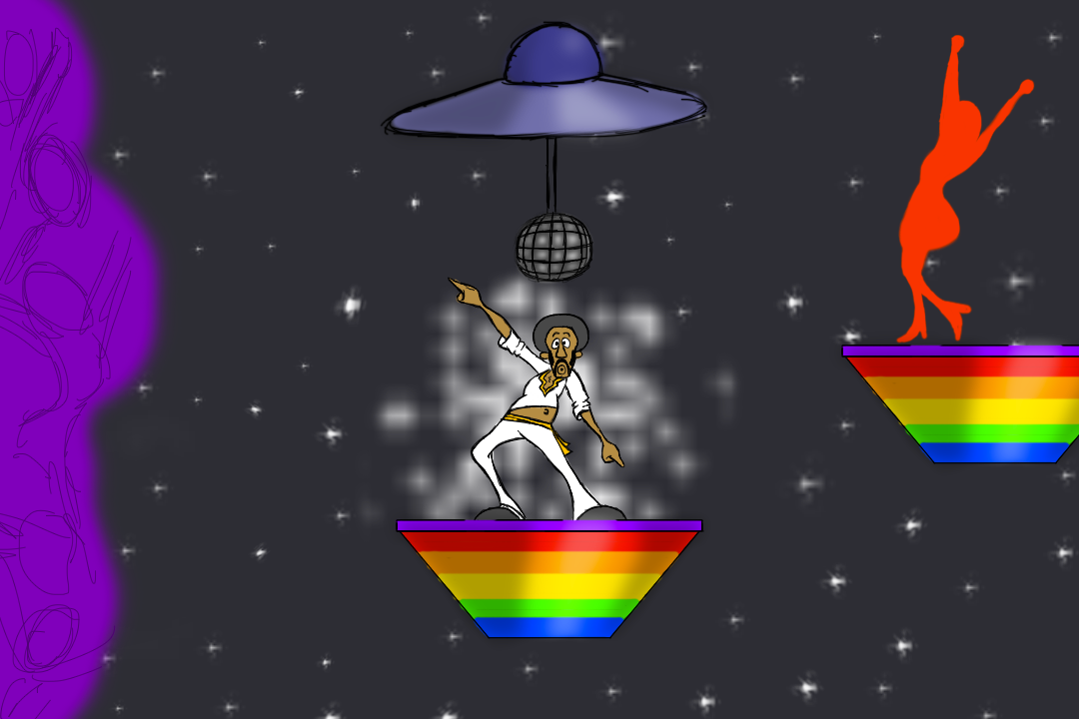

**Overview**

You are an 80’s disco dancer named Daddio McGroove. Your goal is to make your way to the other side of the galactic rainbow. Rainbow platforms will light up and dim along with the rhythm of the music. When lit up, Daddio will be able to land on the platforms. When dim, Daddio will fall through the platforms to his demise, as he no longer has the rhythm. To make matters worse, a legion of colorful dancers, known as the rainbow dancers, will hinder Daddio’s progress.

These mystical dancers want nothing more than to dance all day every day for eternity, and they want Daddio McGroove to do the same. If the rainbow dancers get too close to Daddio, the power of the dance will overwhelm him and overtake his body. The dance craze is dangerous and could potentially cause Daddio McGroove to dance himself off of a cliff into the abyss. Eventually he will be able to break free once the rainbow dancers’ thirst for dance has been slaked.

A meeting with the rainbow dancers is not inevitable, as it may at first seem. The more that Daddio McGroove dances under his own free will, the less the rainbow dancers will harass him.

**Programming**

* Controls
  + Move
  + Jump
  + Dance
* Platforms
  + Lit up during beat
  + Dim during off beat
* Daddio
  + Landing Animation
  + Spring jump animation when landing on a spring platform
  + Randomly choose between the multiple dance animations
* Dancing/Rainbow Dancers
  + Keep track of how much Daddio has been dancing
  + If dancing has been frequent, enemies spawn less often, and the ones that are spawned dance in place instead of attacking Daddio
  + When in nearby vicinity of a rainbow dancer, Move horizontally uncontrollably while forcibly dancing.
  + Rainbow Dancers: Green = Slow, Yellow = Medium, Red = Fast
* Win condition
  + Make it all the way to the end of the level
* Lose condition
  + None, if you fall off the bottom of the screen, you go back to the closest activated checkpoint
* **Cutscene**
  + Black Screen
  + Play Daddio’s moonwalking animation from the left (Starts off screen)
  + When he reaches middle of screen, play idle animation
  + Disco background descends from the top of the screen (Starts off screen)
  + Disco background stops once it fills entire screen
  + After a couple seconds, play dance animation
  + After a few more seconds, rainbow dancers move in from the sides, also dancing (Start off screen)
  + Red is first, yellow is second, green is last
  + Everyone dances for a while
  + UFO descends from top of screen (Starts off screen)
  + Light beam appears below UFO
  + Play Daddio’s abduction animation
  + Light beam, UFO, and Daddio rise up off screen
  + Rainbow Dancers move back off screen (same way they came in, except this time, the red ones move off screen first, then yellow, then green)
  + Disco Background goes down off bottom of screen
  + 1st level Space Background replaces disco background
  + UFO rises from bottom with light beam and Daddio still playing his abduction animation
  + Light beam turns off when Daddio is above a platform
  + UFO continues up off the top of the screen
  + Daddio lands on the platform
  + 1st level starts
* Main Menu
  + Start button
  + Credits button
* Pause Function
  + Pause game
  + Freeze action on screen when paused
  + Continue Button
  + Quit Button

**Animations**

* Daddio McGroove
  + Idle
  + Moonwalk (Walk)
  + Backflip (Jump)
  + Spring Jump (Touch toes in air)
  + Fall
  + Splits (Landing)
  + Dance 1
  + Dance 2
  + Sparkly Respawn
  + Abduction
* Rainbow Dancer
  + Dance 1
  + Dance 2
  + Dance 3
* Dancing Mob
  + Dance
* UFO (Checkpoint)
  + Idle
  + Light Beam
  + Disco Ball Descending
  + Disco Ball Rotating
* Phrases
  + Arrow + “Daddio McGroove” (For Opening Cutscene)
  + “Groovy!”
  + “You’re the cat’s pajamas!”
  + “Far out!”
* Platforms
  + Rainbow Lit Up
  + Rainbow Dim
  + Rainbow Spring
  + Safe Platform
* Backgrounds
  + Outer Space
  + Disco Club